|  |  |  |  |  |  |  |  |
| --- | --- | --- | --- | --- | --- | --- | --- |
| **1** | |  | **INTRODUCTION** | |  |  |  |
|  | |  | **1.1 Overview** | |  |  |  |
|  | |  | **1.2 Purpose** | |  |  |  |
| **2** | |  | **LITERATURE SURVEY** | |  |  |  |
|  | |  | **2.1 Existing problem** | | |  |  |
|  | |  | **2.2 Proposed solution** | | |  |  |
| **3** | |  | **THEORITICAL ANALYSIS** | |  |  |  |
|  | |  | **3.1 Block diagram** | |  |  |  |
|  | |  | **3.2 Hardware / Software designing** | | |  |  |
| **4** | |  | **EXPERIMENTAL INVESTIGATIONS** | | |  |  |
| **5** | |  | **FLOWCHART** | |  |  |  |
| **6** | |  | **RESULT** |  |  |  |  |
| **7** | |  | **ADVANTAGES & DISADVANTAGES** | | |  |  |
| **8** | |  | **APPLICATIONS** | |  |  |  |
| **9** | |  | **CONCLUSION** | |  |  |  |
| **10** | |  | **FUTURE SCOPE** | | **`** |  |  |
| **11** | |  | **BIBILOGRAPHY** | |  |  |  |
|  | |  | **APPENDIX** | |  |  |  |
|  |  | | **A. Source code** | |  |  |  |
|  |  | |  |  |  |  |  |

**1. INTRODUCTION**

**What is a Chatbot?**

**First, let us divide the word “chatbot” into two, so we have “chat” and “bot”**

**Chat is the process of communicating, interacting and exchanging information. Bot is an application which is programmed to think like humans to do certain tasks without human intervention.**

**1.2  Purpose**

**So, interacting or chatting with an AI-based system (Bot) that can understand human language, process it and give reply based on user intent is called a Chatbot.**

**2 LITERATURE SURVEY**

**2.1 Existing Problem**

Currently movie ticket booking is web based by visiting indivdual websites of theatre by manual searching.Consumes more time and viewers do not have knowlege of movies running n other theatres.

**2.2 Proposed Solution**

AI based Movie Ticket Booking chat bot can ather all movies running in all theatres across the given city based on language and can interact with customers to gather their taste and accordingly dsiplays movie list and helps in booking tickets.

USers will have more of conversational type booking activity as in real time.

**3. THEORITICAL ANALYSIS**

**3.1  Block diagram**

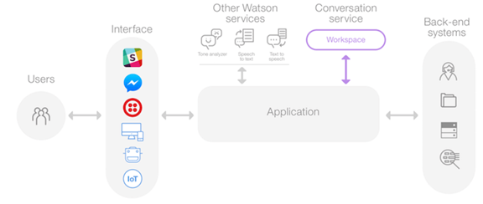

**Fig. 3.1 Block Diaram**

**3.2  Hardware / Software designing**

* You must have an IBM Cloud account. The account is free and provides access to everything you need to develop, track, plan, and deploy apps. [Sign up for a trial](https://cloud.ibm.com/registration?cm_mmc=IBMBluemixGarageMethod-_-MethodSite-_-10-19-15::12-31-18-_-bm_reg). The account requires an IBMid. If you don't have an IBMid, you can create one when you register.
* Your IBM Cloud account must have at least 8 GB of runtime and container memory, plus access to provision up to 10 services.
* You need a clone of [this GitHub repository](https://github.com/ibm-cloud-architecture/refarch-cognitive-conversation-broker), as you might need some of the files to expedite your work.
* To develop on the broker code or to run locally or on IBM Cloud, you must be familiar with Node.js, Express.js, and Angular 2.

**4. EXPERIMENTAL INVESTIGATIONS**

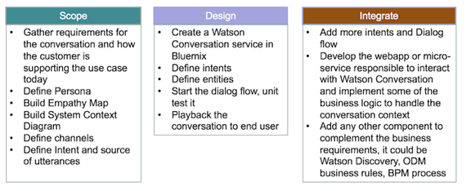

Fig 4.1 Experimental Investigation

**5. FLOWCHART**

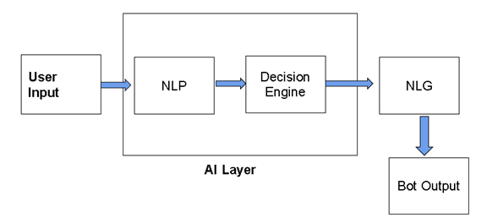

Fig. 5.1

Steps to be followed

[Task 1: Create the Assistant service](https://www.ibm.com/cloud/architecture/tutorials/watson_conversation_support?task=1/)

[Task 2: Create a workspace](https://www.ibm.com/cloud/architecture/tutorials/watson_conversation_support?task=2/)

[Task 3: Create intents](https://www.ibm.com/cloud/architecture/tutorials/watson_conversation_support?task=3/)

[Task 4: Test the intents](https://www.ibm.com/cloud/architecture/tutorials/watson_conversation_support?task=4/)

[Task 5: Add entities](https://www.ibm.com/cloud/architecture/tutorials/watson_conversation_support?task=5/)

[Task 6: Build the dialog](https://www.ibm.com/cloud/architecture/tutorials/watson_conversation_support?task=6/)

[Task 7: Complete advanced dialog work](https://www.ibm.com/cloud/architecture/tutorials/watson_conversation_support?task=7/)

6. **RESULTS**

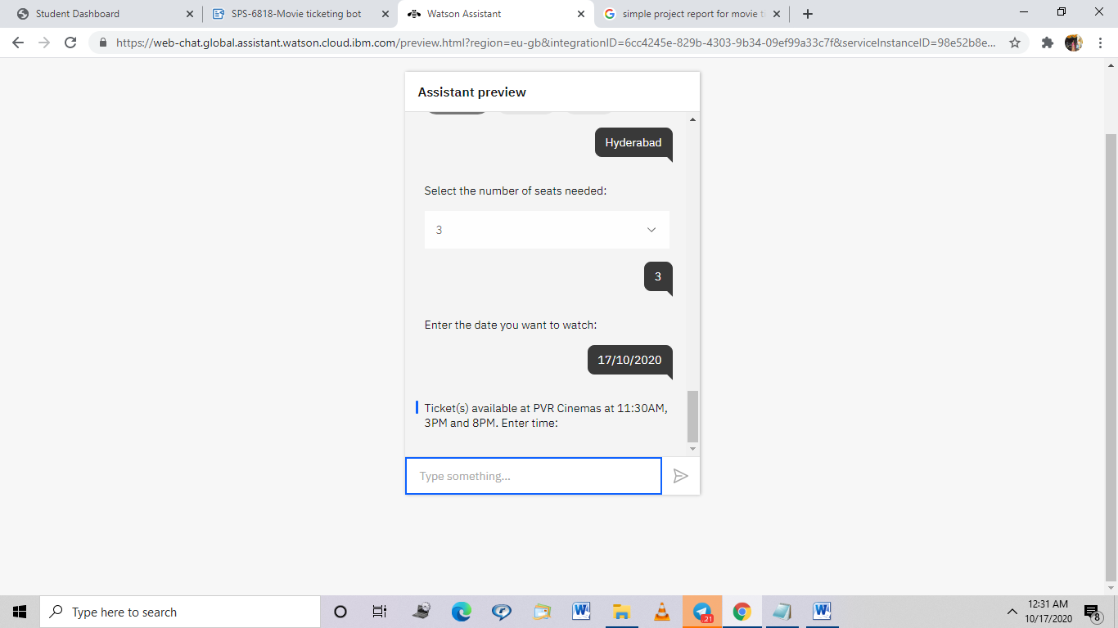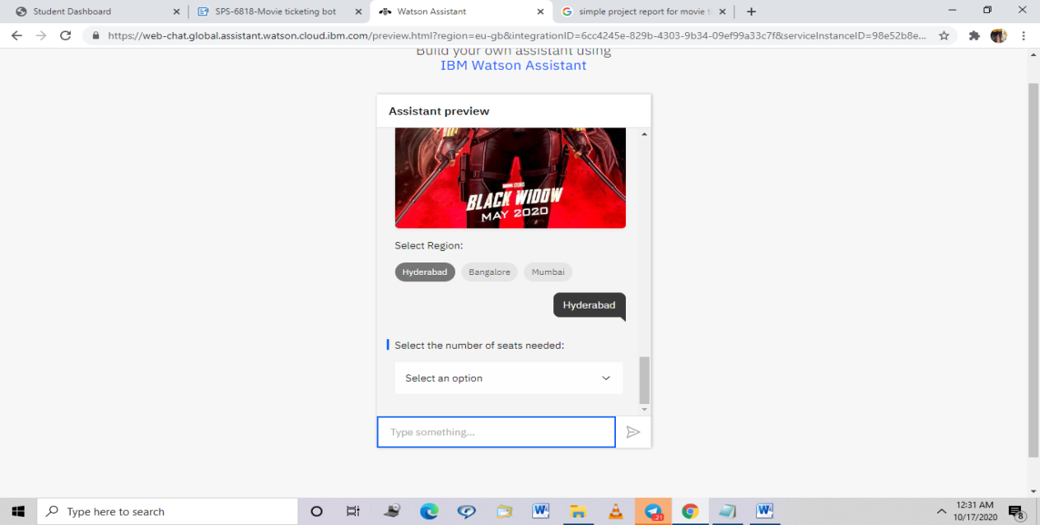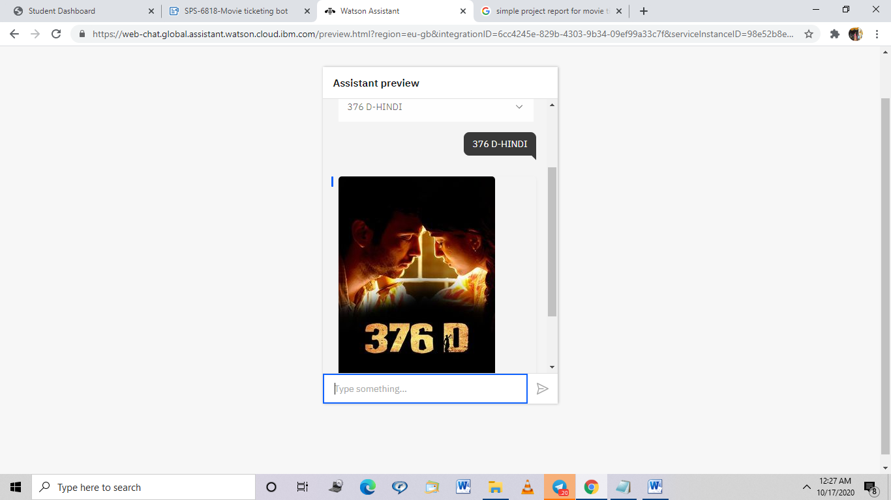

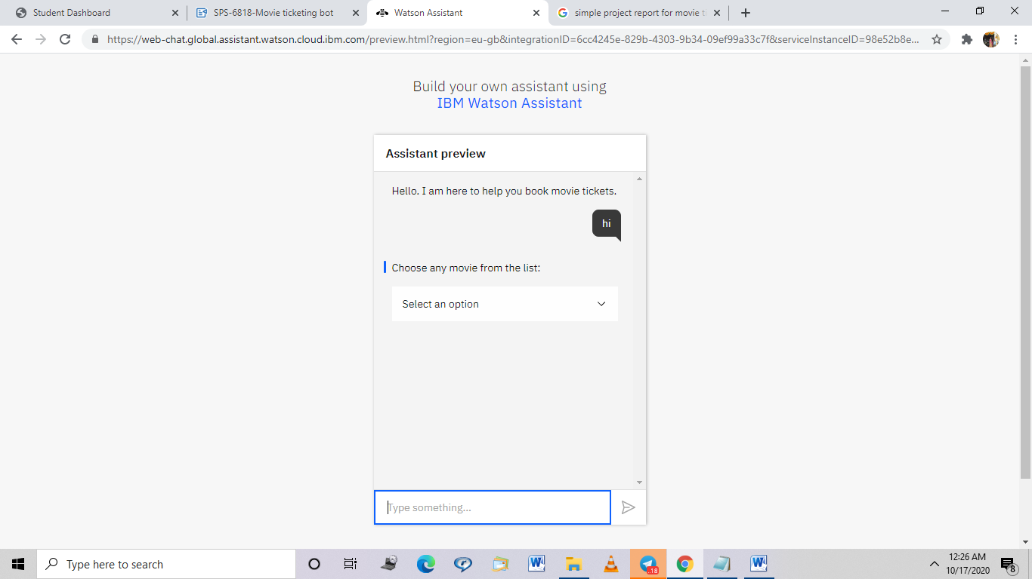

**7. ADVANTAGES & DISADVANTAGES**

**Advantages**

1. **Very interactive**
2. **Real time booking experience**
3. **Any type of users irrespective of computer knowldge and age can use it**

**Disadvantages**

1. **Now it is restricted to 3 regions**
2. **Bot has to learn over a period of time so requires more training**

**8. APPLICATIONS**

1. **Useful for any set of people**
2. **Bridges ap between customer to business and business to customers**
3. **Lite weight**
4. **Can be incorporated in mobile/website**

**9. CONCLUSION**

chatbots are computer applications powered by artificial intelligence to communicate with you. They are designed to mimic natural human conversation via an online chat interface, SMS, and sometimes, even voice chat.

10. **FUTURE SCOPE**

Despite being designed for human consumption, chatbots are also capable of communicating and gathering information from other chatbots.

Can be deeloped to chat in local language depending on location access.

11. **BIBILOGRAPHY**

**1.  https://cdn2.hubspot.net/**

**2. www.developer.ibm.com**

**3. www.google.com**

|  |
| --- |
| **APPENDIX** |
| * 1. **Source code**   **{**  **"intents": [**  **{**  **"intent": "greetings",**  **"examples": [**  **{**  **"text": "Hello"**  **},**  **{**  **"text": "Hi"**  **},**  **{**  **"text": "Ok"**  **},**  **{**  **"text": "Okay"**  **}**  **],**  **"description": ""**  **},**  **{**  **"intent": "otp",**  **"examples": [**  **{**  **"text": "12AB"**  **}**  **],**  **"description": ""**  **},**  **{**  **"intent": "seats",**  **"examples": [**  **{**  **"text": "1"**  **},**  **{**  **"text": "2"**  **},**  **{**  **"text": "3"**  **},**  **{**  **"text": "4"**  **},**  **{**  **"text": "5"**  **},**  **{**  **"text": "6"**  **}**  **],**  **"description": ""**  **},**  **{**  **"intent": "thankyou",**  **"examples": [**  **{**  **"text": "Thanks"**  **},**  **{**  **"text": "Thank you"**  **}**  **],**  **"description": ""**  **},**  **{**  **"intent": "time",**  **"examples": [**  **{**  **"text": "11:30AM"**  **},**  **{**  **"text": "11:30 AM"**  **},**  **{**  **"text": "3PM"**  **},**  **{**  **"text": "3 PM"**  **},**  **{**  **"text": "8PM"**  **},**  **{**  **"text": "8 PM"**  **}**  **],**  **"description": ""**  **}**  **],**  **"entities": [**  **{**  **"entity": "movie",**  **"values": [**  **{**  **"type": "synonyms",**  **"value": "376 D-HINDI",**  **"synonyms": []**  **},**  **{**  **"type": "synonyms",**  **"value": "Black Widow-ENGLISH",**  **"synonyms": []**  **},**  **{**  **"type": "synonyms",**  **"value": "Ginny Weds Sunny-HINDI",**  **"synonyms": []**  **},**  **{**  **"type": "synonyms",**  **"value": "Ila Naa Jathaga-TELUGU",**  **"synonyms": []**  **},**  **{**  **"type": "synonyms",**  **"value": "Kaaliyan-MALAYALAM",**  **"synonyms": []**  **},**  **{**  **"type": "synonyms",**  **"value": "Namaste India-KANNADA",**  **"synonyms": []**  **},**  **{**  **"type": "synonyms",**  **"value": "Sampati-BENGALI",**  **"synonyms": []**  **},**  **{**  **"type": "synonyms",**  **"value": "Soorarai Pottru-TAMIL",**  **"synonyms": []**  **},**  **{**  **"type": "synonyms",**  **"value": "The Big Bull-HINDI",**  **"synonyms": []**  **},**  **{**  **"type": "synonyms",**  **"value": "The Lie-ENGLISH",**  **"synonyms": []**  **}**  **],**  **"fuzzy_match": true**  **},**  **{**  **"entity": "region",**  **"values": [**  **{**  **"type": "synonyms",**  **"value": "Bangalore",**  **"synonyms": []**  **},**  **{**  **"type": "synonyms",**  **"value": "Hyderabad",**  **"synonyms": []**  **},**  **{**  **"type": "synonyms",**  **"value": "Mumbai",**  **"synonyms": []**  **}**  **],**  **"fuzzy_match": true**  **},**  **{**  **"entity": "sys-date",**  **"values": [],**  **"fuzzy_match": true**  **},**  **{**  **"entity": "sys-number",**  **"values": [],**  **"fuzzy_match": true**  **}**  **],**  **"metadata": {**  **"api_version": {**  **"major_version": "v2",**  **"minor_version": "2018-11-08"**  **}**  **},**  **"dialog_nodes": [**  **{**  **"type": "standard",**  **"title": "Anything else",**  **"output": {**  **"generic": [**  **{**  **"values": [**  **{**  **"text": "I didn't understand. You can try rephrasing."**  **},**  **{**  **"text": "Can you reword your statement? I'm not understanding."**  **},**  **{**  **"text": "I didn't get your meaning."**  **}**  **],**  **"response_type": "text",**  **"selection_policy": "sequential"**  **}**  **]**  **},**  **"conditions": "anything_else",**  **"dialog_node": "Anything else",**  **"previous_sibling": "node_3_1602051074676",**  **"disambiguation_opt_out": true**  **},**  **{**  **"type": "standard",**  **"output": {**  **"generic": [**  **{**  **"values": [**  **{**  **"text": "Enter the date you want to watch:"**  **}**  **],**  **"response_type": "text",**  **"selection_policy": "sequential"**  **}**  **]**  **},**  **"conditions": "#seats",**  **"dialog_node": "node_2_1602050554341",**  **"previous_sibling": "node_5_1602050341114"**  **},**  **{**  **"type": "standard",**  **"output": {**  **"generic": [**  **{**  **"source": "https://encrypted-tbn0.gstatic.com/images?q=tbn%3AANd9GcSzUlbodCsvfdaX3Yeq6HffABHsMlbOUrRsPg&usqp=CAU",**  **"response_type": "image"**  **},**  **{**  **"title": "Select Region:",**  **"options": [**  **{**  **"label": "Hyderabad",**  **"value": {**  **"input": {**  **"text": "Hyderabad"**  **}**  **}**  **},**  **{**  **"label": "Bangalore",**  **"value": {**  **"input": {**  **"text": "Bangalore"**  **}**  **}**  **},**  **{**  **"label": "Mumbai",**  **"value": {**  **"input": {**  **"text": "Mumbai"**  **}**  **}**  **}**  **],**  **"response_type": "option"**  **}**  **]**  **},**  **"conditions": "@movie:(The Big Bull-HINDI)",**  **"dialog_node": "node_3_1602050158612",**  **"previous_sibling": "node_5_1602050066768"**  **},**  **{**  **"type": "standard",**  **"output": {**  **"generic": [**  **{**  **"source": "https://encrypted-tbn0.gstatic.com/images?q=tbn%3AANd9GcSQ6ePgT64x2f0M0Uzee0YyGU7wsz9912JUoQ&usqp=CAU",**  **"response_type": "image"**  **}**  **]**  **},**  **"conditions": "#thankyou",**  **"dialog_node": "node_3_1602051074676",**  **"previous_sibling": "node_7_1602050963732"**  **},**  **{**  **"type": "standard",**  **"output": {**  **"generic": [**  **{**  **"source": "https://external-content.duckduckgo.com/iu/?u=https%3A%2F%2Ftse2.mm.bing.net%2Fth%3Fid%3DOIP.DsVtbg8Phhv4WPqLdGJkzQHaKT%26pid%3DApi&f=1",**  **"response_type": "image"**  **},**  **{**  **"title": "Select Region:",**  **"options": [**  **{**  **"label": "Hyderabad",**  **"value": {**  **"input": {**  **"text": "Hyderabad"**  **}**  **}**  **},**  **{**  **"label": "Bangalore",**  **"value": {**  **"input": {**  **"text": "Bangalore"**  **}**  **}**  **},**  **{**  **"label": "Mumbai",**  **"value": {**  **"input": {**  **"text": "Mumbai"**  **}**  **}**  **}**  **],**  **"response_type": "option"**  **}**  **]**  **},**  **"conditions": "@movie:(Black Widow-ENGLISH)",**  **"dialog_node": "node_5_1602049558927",**  **"previous_sibling": "node_8_1602049000837"**  **},**  **{**  **"type": "standard",**  **"output": {**  **"generic": [**  **{**  **"source": "https://encrypted-tbn0.gstatic.com/images?q=tbn%3AANd9GcQ7LPzI0n5nOpdyuQFF_4_cYYcM27q5QXePGA&usqp=CAU",**  **"response_type": "image"**  **},**  **{**  **"title": "Select Region:",**  **"options": [**  **{**  **"label": "Hyderabad",**  **"value": {**  **"input": {**  **"text": "Hyderabad"**  **}**  **}**  **},**  **{**  **"label": "Bangalore",**  **"value": {**  **"input": {**  **"text": "Bangalore"**  **}**  **}**  **},**  **{**  **"label": "Mumbai",**  **"value": {**  **"input": {**  **"text": "Mumbai"**  **}**  **}**  **}**  **],**  **"response_type": "option"**  **}**  **]**  **},**  **"conditions": "@movie:(Ginny Weds Sunny-HINDI)",**  **"dialog_node": "node_5_1602050066768",**  **"previous_sibling": "node_9_1602049992006"**  **},**  **{**  **"type": "standard",**  **"output": {**  **"generic": [**  **{**  **"title": "Select the number of seats needed:",**  **"options": [**  **{**  **"label": "1",**  **"value": {**  **"input": {**  **"text": "1"**  **}**  **}**  **},**  **{**  **"label": "2",**  **"value": {**  **"input": {**  **"text": "2"**  **}**  **}**  **},**  **{**  **"label": "3",**  **"value": {**  **"input": {**  **"text": "3"**  **}**  **}**  **},**  **{**  **"label": "4",**  **"value": {**  **"input": {**  **"text": "4"**  **}**  **}**  **},**  **{**  **"label": "5",**  **"value": {**  **"input": {**  **"text": "5"**  **}**  **}**  **},**  **{**  **"label": "6",**  **"value": {**  **"input": {**  **"text": "6"**  **}**  **}**  **}**  **],**  **"response_type": "option"**  **}**  **]**  **},**  **"conditions": "@region",**  **"dialog_node": "node_5_1602050341114",**  **"previous_sibling": "node_3_1602050158612"**  **},**  **{**  **"type": "standard",**  **"output": {**  **"generic": [**  **{**  **"values": [**  **{**  **"text": "Ticket(s) available at PVR Cinemas at 11:30AM, 3PM and 8PM. Enter time:"**  **}**  **],**  **"response_type": "text",**  **"selection_policy": "sequential"**  **}**  **]**  **},**  **"conditions": "@sys-date",**  **"dialog_node": "node_5_1602050593967",**  **"previous_sibling": "node_2_1602050554341"**  **},**  **{**  **"type": "standard",**  **"output": {**  **"generic": [**  **{**  **"values": [**  **{**  **"text": "OTP is sent to the number. Enter OTP:"**  **}**  **],**  **"response_type": "text",**  **"selection_policy": "sequential"**  **}**  **]**  **},**  **"conditions": "@sys-number",**  **"dialog_node": "node_5_1602050869689",**  **"previous_sibling": "node_7_1602050804048"**  **},**  **{**  **"type": "standard",**  **"output": {**  **"generic": [**  **{**  **"source": "https://encrypted-tbn0.gstatic.com/images?q=tbn%3AANd9GcQjbqPMJxnhkU7pZH3oX4cMT1yx4YbwANk2qQ&usqp=CAU",**  **"response_type": "image"**  **},**  **{**  **"title": "Select Region:",**  **"options": [**  **{**  **"label": "Hyderabad",**  **"value": {**  **"input": {**  **"text": "Hyderabad"**  **}**  **}**  **},**  **{**  **"label": "Bangalore",**  **"value": {**  **"input": {**  **"text": "Bangalore"**  **}**  **}**  **},**  **{**  **"label": "Mumbai",**  **"value": {**  **"input": {**  **"text": "Mumbai"**  **}**  **}**  **}**  **],**  **"response_type": "option"**  **}**  **]**  **},**  **"conditions": "@movie:(Soorarai Pottru-TAMIL)",**  **"dialog_node": "node_6_1602049870829",**  **"previous_sibling": "node_9_1602049782565"**  **},**  **{**  **"type": "standard",**  **"output": {**  **"generic": [**  **{**  **"values": [**  **{**  **"text": "Okay. Enter mobile Number:"**  **}**  **],**  **"response_type": "text",**  **"selection_policy": "sequential"**  **}**  **]**  **},**  **"conditions": "#time",**  **"dialog_node": "node_7_1602050804048",**  **"previous_sibling": "node_5_1602050593967"**  **},**  **{**  **"type": "standard",**  **"output": {**  **"generic": [**  **{**  **"values": [**  **{**  **"text": "Ticket details are sent to your mobile. Complete payment and book the slot. Thank you for using our service."**  **}**  **],**  **"response_type": "text",**  **"selection_policy": "sequential"**  **}**  **]**  **},**  **"conditions": "#otp",**  **"dialog_node": "node_7_1602050963732",**  **"previous_sibling": "node_5_1602050869689"**  **},**  **{**  **"type": "standard",**  **"output": {**  **"generic": [**  **{**  **"title": "Choose any movie from the list:",**  **"options": [**  **{**  **"label": "Black Widow-ENGLISH",**  **"value": {**  **"input": {**  **"text": "Black Widow-ENGLISH"**  **}**  **}**  **},**  **{**  **"label": "376 D-HINDI",**  **"value": {**  **"input": {**  **"text": "376 D-HINDI"**  **}**  **}**  **},**  **{**  **"label": "Ginny Weds Sunny-HINDI",**  **"value": {**  **"input": {**  **"text": "Ginny Weds Sunny-HINDI"**  **}**  **}**  **},**  **{**  **"label": "The Lie-ENGLISH",**  **"value": {**  **"input": {**  **"text": "The Lie-ENGLISH"**  **}**  **}**  **},**  **{**  **"label": "The Big Bull-HINDI",**  **"value": {**  **"input": {**  **"text": "The Big Bull-HINDI"**  **}**  **}**  **},**  **{**  **"label": "Soorarai Pottru-TAMIL",**  **"value": {**  **"input": {**  **"text": "Soorarai Pottru-TAMIL"**  **}**  **}**  **},**  **{**  **"label": "Namaste India-KANNADA",**  **"value": {**  **"input": {**  **"text": "Namaste India-KANNADA"**  **}**  **}**  **},**  **{**  **"label": "Kaaliyan-MALAYALAM",**  **"value": {**  **"input": {**  **"text": "Kaaliyan-MALAYALAM"**  **}**  **}**  **},**  **{**  **"label": "Ila Naa Jathaga-TELUGU",**  **"value": {**  **"input": {**  **"text": "Ila Naa Jathaga-TELUGU"**  **}**  **}**  **},**  **{**  **"label": "Sampati-BENGALI",**  **"value": {**  **"input": {**  **"text": "Sampati-BENGALI"**  **}**  **}**  **}**  **],**  **"response_type": "option"**  **}**  **]**  **},**  **"conditions": "#greetings",**  **"dialog_node": "node_8_1602049000837",**  **"previous_sibling": "Welcome"**  **},**  **{**  **"type": "standard",**  **"output": {**  **"generic": [**  **{**  **"source": "https://in.bmscdn.com/iedb/movies/images/mobile/thumbnail/large/376-d-et00145101-01-10-2020-11-30-22.jpg",**  **"response_type": "image"**  **},**  **{**  **"title": "Select Region:",**  **"options": [**  **{**  **"label": "Hyderabad",**  **"value": {**  **"input": {**  **"text": "Hyderabad"**  **}**  **}**  **},**  **{**  **"label": "Bangalore",**  **"value": {**  **"input": {**  **"text": "Bangalore"**  **}**  **}**  **},**  **{**  **"label": "Mumbai",**  **"value": {**  **"input": {**  **"text": "Mumbai"**  **}**  **}**  **}**  **],**  **"response_type": "option"**  **}**  **]**  **},**  **"conditions": "@movie:(376 D-HINDI)",**  **"dialog_node": "node_9_1602049782565",**  **"previous_sibling": "node_5_1602049558927"**  **},**  **{**  **"type": "standard",**  **"output": {**  **"generic": [**  **{**  **"source": "https://www.letsott.com/assets/uploads/posts/the-lie-amazon-prime-video-min.jpg",**  **"response_type": "image"**  **},**  **{**  **"title": "Select Region:",**  **"options": [**  **{**  **"label": "Hyderabad",**  **"value": {**  **"input": {**  **"text": "Hyderabad"**  **}**  **}**  **},**  **{**  **"label": "Bangalore",**  **"value": {**  **"input": {**  **"text": "Bangalore"**  **}**  **}**  **},**  **{**  **"label": "Mumbai",**  **"value": {**  **"input": {**  **"text": "Mumbai"**  **}**  **}**  **}**  **],**  **"response_type": "option"**  **}**  **]**  **},**  **"conditions": "@movie:(The Lie-ENGLISH)",**  **"dialog_node": "node_9_1602049992006",**  **"previous_sibling": "node_6_1602049870829"**  **},**  **{**  **"type": "standard",**  **"title": "Welcome",**  **"output": {**  **"generic": [**  **{**  **"values": [**  **{**  **"text": "Hello. I am here to help you book movie tickets."**  **}**  **],**  **"response_type": "text",**  **"selection_policy": "sequential"**  **}**  **]**  **},**  **"conditions": "welcome",**  **"dialog_node": "Welcome"**  **}**  **],**  **"counterexamples": [],**  **"system_settings": {**  **"off_topic": {**  **"enabled": true**  **},**  **"disambiguation": {**  **"prompt": "Did you mean:",**  **"enabled": true,**  **"randomize": true,**  **"max_suggestions": 5,**  **"suggestion_text_policy": "title",**  **"none_of_the_above_prompt": "None of the above"**  **},**  **"system_entities": {**  **"enabled": true**  **},**  **"human_agent_assist": {**  **"prompt": "Did you mean:"**  **},**  **"spelling_auto_correct": true**  **},**  **"learning_opt_out": false,**  **"name": "MTBooking",**  **"language": "en",**  **"description": ""**  **}** |
|  |